Electronics Documentation

Electronics Block Diagram
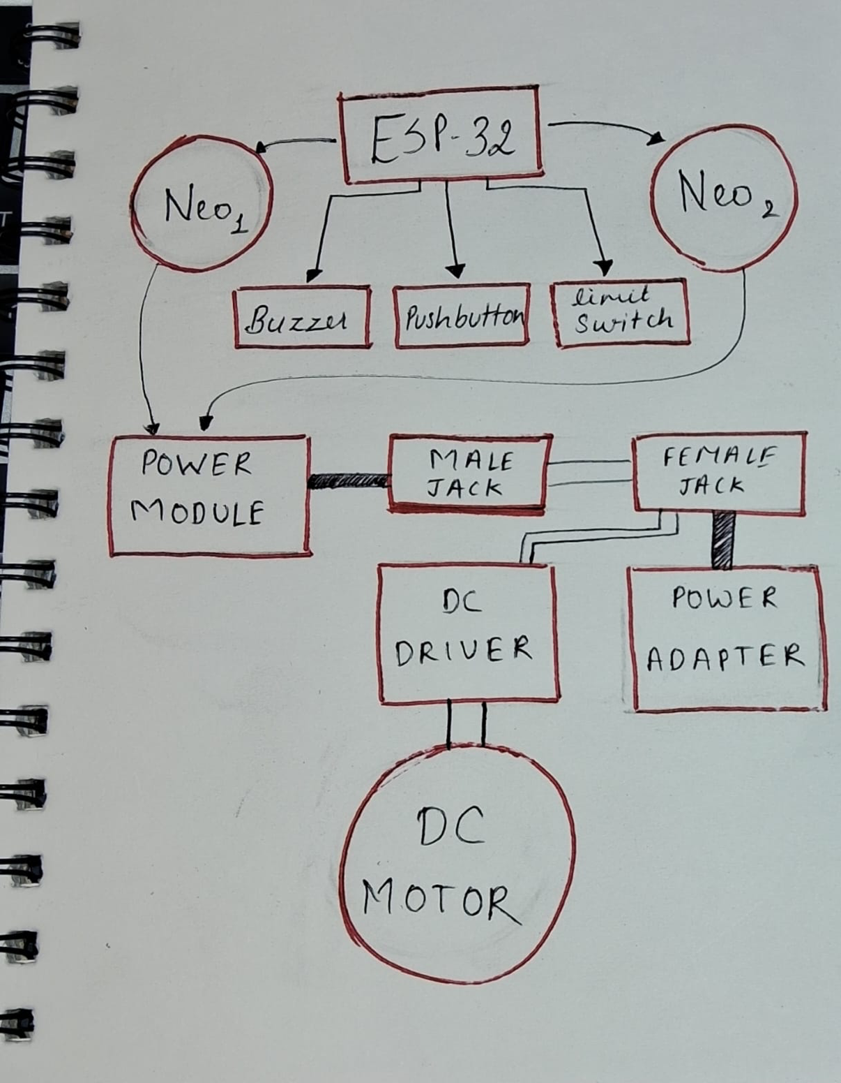

2. Components Table
Component | Quantity | Purpose | Justification
ESP32 | 1 | Main controller for system | Acts as the central unit managing all inputs, outputs, and web based control
Limit Switch | 1 | Detects trigger press in gun prop | Used as a tactile input mechanism to activate the buzzer when the trigger is pressed
Push Button | 1 | User input to start motor system | Provides a simple and reliable way to initiate the main interaction
Buzzer | 1 | Produces sound effect (pew pew) | Adds an auditory response to user action, enhancing interactivity
Neo pixel Rings | 2 | Lighting and visual effects | Enables dynamic, programmable lighting to create an immersive experience
DC Motor | 1 | Rotates the arm structure with CDs | Generates continuous motion required for reflective light effects
Motor Driver | 1 | Controls DC motor | Supplies current ,allows control from ESP32
DC Jack (Male/Female) | 1 set | Connects power supply to circuit | Provides a secure and detachable connection for power input
Power Module | 1 | Regulates power distribution | Ensures stable voltage supply across all components

